**Pipe and Redirection Operations Assignment**

1. Create a script named “myscript” in current directory to do the following.

a) create a dir named “subd1” in current directory – **mkdir subd1**

b) create a file named “dircontent” with contents of the current directory – **ls > dircontent**

c) display the contents of the file “dircontent” – **cat dircontent**

d) display the contents of a non existing file named “unknownfile” – **cat unknownfile.txt**

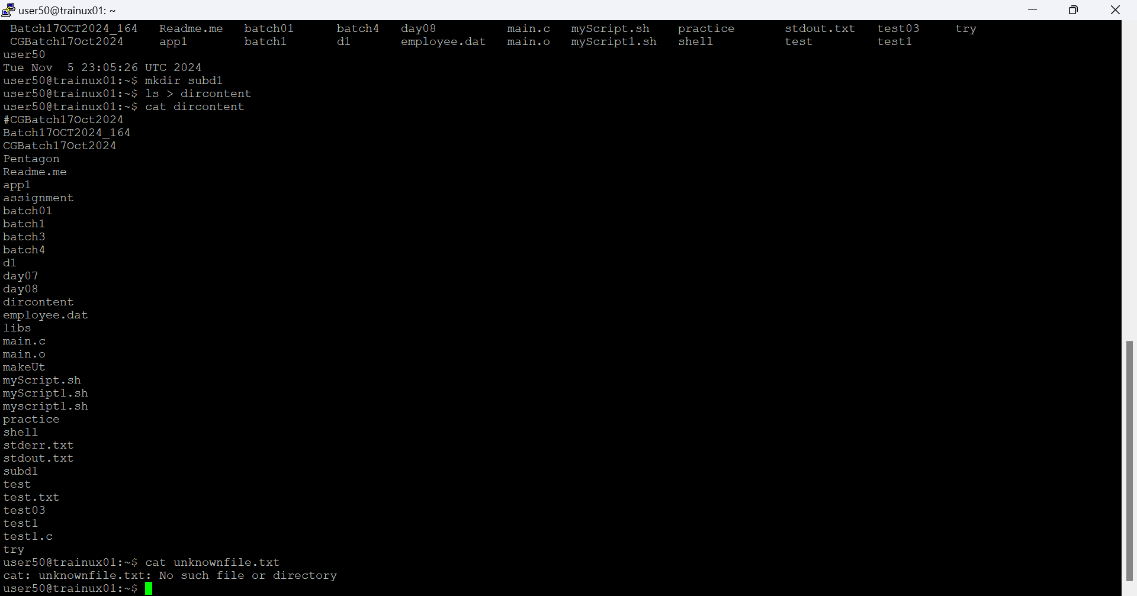

**It should be in executable file format before we run**

2. Run the script and validate the output in following cases

a) Redirect only the stdout to an o/p file named stdout.txt



b) Redirect only the stderr to an o/p file named stderr.txt



c) Redirect both stdout and stderr to an o/p file named stdall.txt



d) Display all o/p and error and also redirect both stdout and stderr to an o/p file named stdall.txt

3. Redirect the output of command below using pipe (|) to wc and get the output . – **ls -l | wc**

